Project Planning Phase
Project Planning Template (Product Backlog, Sprint Planning, Stories, Story points)

Date | 15 February 2025
Team ID | SWTID-2026-2491
Project Name | AI BlogNest API
Maximum Marks | 5 Marks

Product Backlog, Sprint Schedule, and Estimation (4 Marks)
AI BlogNest API: Product Backlog and Sprint Schedule
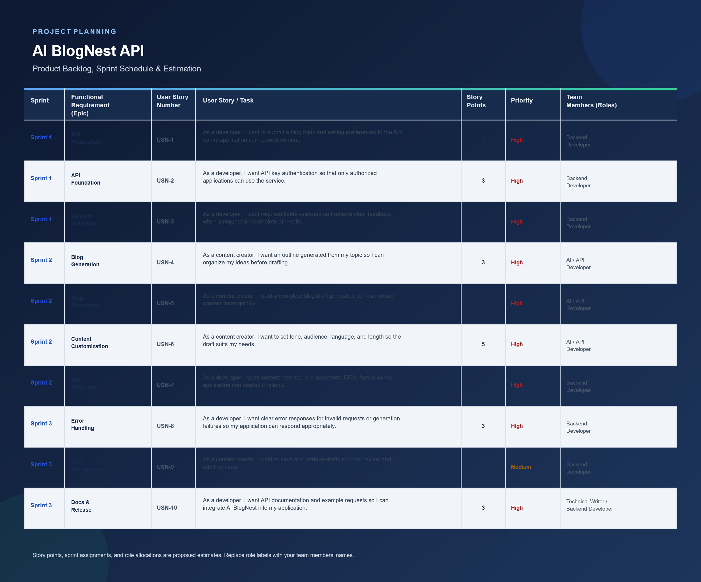

Project Tracker, Velocity & Burndown Chart: (4 Marks)
Sprint | Total Story Points | Duration | Sprint Start Date | Sprint End Date (Planned) | Story Points Completed (as on Planned End Date) | Sprint Release Date (Actual)
Sprint-1 | 20 | 6 Days | 24 Oct 2022 | 29 Oct 2022 | 20 | 29 Oct 2022
Sprint-2 | 20 | 6 Days | 31 Oct 2022 | 05 Nov 2022
Sprint-3 | 20 | 6 Days | 07 Nov 2022 | 12 Nov 2022
Sprint-4 | 20 | 6 Days | 14 Nov 2022 | 19 Nov 2022

Velocity:
Imagine we have a 10-day sprint duration, and the velocity of the team is 20 (points per sprint). Let’s calculate the team’s average velocity (AV) per iteration unit (story points per day)


Burndown Chart:
A burn down chart is a graphical representation of work left to do versus time. It is often used in agile software development methodologies such as Scrum. However, burn down charts can be applied to any project containing measurable progress over time.

https://www.visual-paradigm.com/scrum/scrum-burndown-chart/
https://www.atlassian.com/agile/tutorials/burndown-charts

Reference:
https://www.atlassian.com/agile/project-management
https://www.atlassian.com/agile/tutorials/how-to-do-scrum-with-jira-software
https://www.atlassian.com/agile/tutorials/epics
https://www.atlassian.com/agile/tutorials/sprints
https://www.atlassian.com/agile/project-management/estimation
https://www.atlassian.com/agile/tutorials/burndown-charts

